Results to date

Group Website


The group set out to complete the group web site, where we would record the minutes and logs of every meeting held with the supervisor. Other things included in this site were the option to store code and other materials related to our group project this would serve as a backup in case any work was lost.
The group website also had a brief description of the project on the website this was so visitors to the website could understand what our project was set out to aim.

Algorithm implemented in Java

import java.util.Scanner;

public class mark {

public static void main(String[] a) {

double weight = 0.6;
double givenMark = 70;

System.out.print("Please type the weight from 0 to 1 ");
Scanner input = new Scanner(System.in);
weight = input.nextDouble();

System.out.print("Please type the group mark ");
Scanner input2 = new Scanner(System.in);
givenMark = input.nextDouble();

double[][] student = { { 5, 5, 5, 5, 5, 5 }, { 2, 3, 1, 1, 3, 4 },
{ 3, 5, 4, 1, 5, 0 }, { 1, 4, 2, 2, 3, 1 },
{ 1, 1, 3, 4, 5, 0 }, { 1, 2, 3, 5, 4, 1 } };

double[] Average = new double[student.length];

for (int n = 0; n <= student.length - 1; n++) {

Average[n] = average(student[n]);

}

double AverageGroup = average(Average);

double[] individual = new double[student.length];

for (int n = 0; n <= student.length - 1; n++) {

individual[n] = (1 + weight * (Average[n] / AverageGroup - 1))
* givenMark;

}
// (1 + k * (IRNPR / AVGIRNPR - 1)) * M

for (int n = 0; n <= individual.length - 1; n++) {

if ((int) individual[n] > 100)
System.out.print("The NO." + (n + 1)
+ " student's individual mark is 100" + "\n");
else
System.out.print("The NO." + (n + 1)
+ " student's individual mark is "
+ (int) individual[n] + "\n");
System.out.print("The NO." + (n + 1)
+ " student's individual mark is " + (int) individual[n]
+ "\n");

}

}

static double average(double[] data) {

double x = 0;
int len = data.length;

for (int n = 0; n <= len - 1; n++) {

x = x + data[n];

}

return (double) x / len;

}

}

Above is the algorithm to work out the score of individual marks for a group the user can also edit the weighting which changes the overall score of an individual mark. The algorithm is so far implemented in java and in the future will be implemented into the working peer assessment website

Wireframe prototypes of peer assessment website

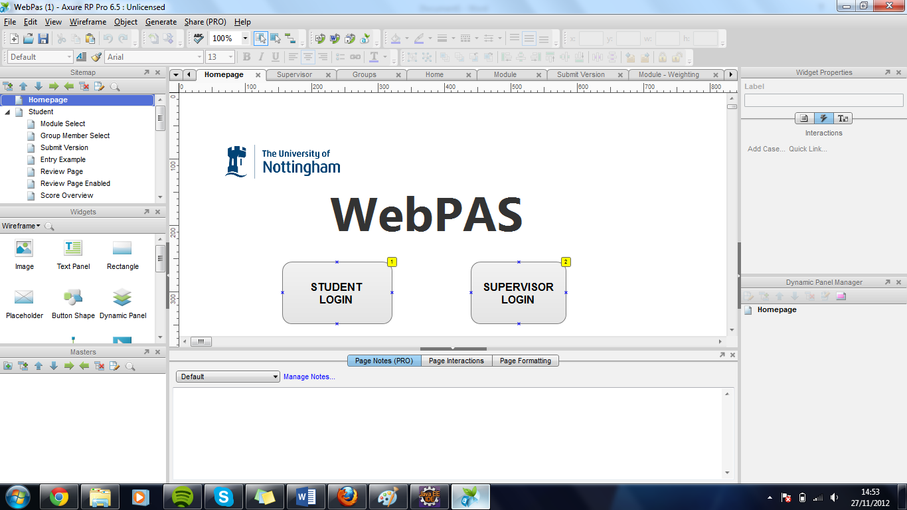
Above is the wireframes for the prototype of the peer assessment website which was completed in a software package called axure. We completed a wireframe for each page in the website for the prototype, as you can see is the above wireframe is for the websites home page which will be the first page the user will see. It has two options: a student login and a supervisor login.
Student login wireframe: this wireframe included a login page that the students will use to login into their side of the website. The student side of the web site will include:
.Group member select wireframe- this part of the website allows a student to select another student in their group to do their peer assessment on.
.Take Assessment wireframe – once a student has selected another student from their group it will take them to the assessment page which will allow them to answer questions on how they felt that particular group member performed for the group work.
.Comment page after assessment wireframe- this is a comment page that will show up after the assessment has been completed this allows the student to justify the answers they gave for that students work in the group

.Score for that student wireframe- this page will display the overall score for that student. This will be the score given to them judged on a peer assessment and if the module convenor felt it was a fair score.
Module convenor login wireframe- this wireframe allows a module convenor to sign in to the module convenor part of the website. The module convenor part of the website will include:
.graphs wireframe- this wireframe displayed a graph which showed the overall marks for the individual members of a group.
.modules wireframe- this wireframe gave the module convenor an option to select a peer assessment for a particular module.
.groups wireframe- this allowed the module convenor to set groups up and view if each member within the group had completed a peer assessment for the other group members
.students- this allows the convenor to select individual students and set them into groups it also allows them to import students from a CSV file.

ER Diagram

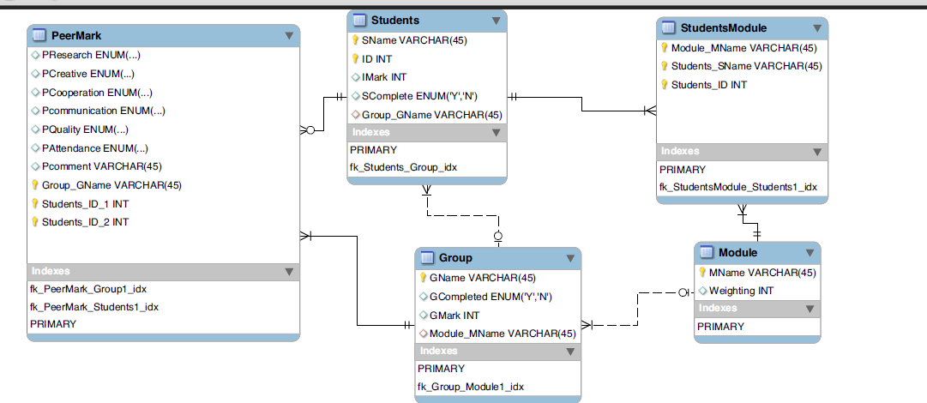
Above is a ER diagram for our database it shows within it the different entity groups and also the primary keys for each entity group.

SQL Create for different tables

SET @OLD_UNIQUE_CHECKS=@@UNIQUE_CHECKS, UNIQUE_CHECKS=0;
SET @OLD_FOREIGN_KEY_CHECKS=@@FOREIGN_KEY_CHECKS, FOREIGN_KEY_CHECKS=0;
SET @OLD_SQL_MODE=@@SQL_MODE, SQL_MODE='TRADITIONAL,ALLOW_INVALID_DATES';

CREATE SCHEMA IF NOT EXISTS `mydb` DEFAULT CHARACTER SET latin1 COLLATE latin1_swedish_ci ;
USE `mydb` ;

-- -----------------------------------------------------
-- Table `mydb`.`Module`
-- -----------------------------------------------------
DROP TABLE IF EXISTS `mydb`.`Module` ;

CREATE TABLE IF NOT EXISTS `mydb`.`Module` (
`ModuleName` VARCHAR(20) NOT NULL ,
`Weighting` INT NULL ,
PRIMARY KEY (`ModuleName`) )
ENGINE = InnoDB;

As you can see the above contains the SQL create for the module table it includes the entity’s for that table as well as what they can accept in the field and the primary key of that table.

-- -----------------------------------------------------
-- Table `mydb`.`Group`
-- -----------------------------------------------------
DROP TABLE IF EXISTS `mydb`.`Group` ;

CREATE TABLE IF NOT EXISTS `mydb`.`Group` (
`GroupName` VARCHAR(20) NOT NULL ,
`Completed` VARCHAR(10) NULL ,
`Mark` INT NULL ,
`Module_ModuleName` VARCHAR(20) NOT NULL ,
PRIMARY KEY (`GroupName`) ,
INDEX `fk_Group_Module1_idx` (`Module_ModuleName` ASC) ,
CONSTRAINT `fk_Group_Module1`
FOREIGN KEY (`Module_ModuleName` )
REFERENCES `mydb`.`Module` (`ModuleName` )
ON DELETE NO ACTION
ON UPDATE NO ACTION)
ENGINE = InnoDB;
The above shows the SQL create for the table group. Within the table group it should hold the entities:
.group name
.completed
.Mark
.Module name
The primary key has also been set as well as the foreign keys.

-- -----------------------------------------------------
-- Table `mydb`.`Assessment`
-- -----------------------------------------------------
DROP TABLE IF EXISTS `mydb`.`Assessment` ;

CREATE TABLE IF NOT EXISTS `mydb`.`Assessment` (
`1. Research and Information gathering` VARCHAR(45) NOT NULL ,
`2. Creative Input` VARCHAR(45) NOT NULL ,
`3. Cooperation with group` VARCHAR(45) NOT NULL ,
`4. Communication with group` VARCHAR(45) NOT NULL ,
`5. Quality of individual contributions` VARCHAR(45) NOT NULL ,
`6. Attendance at meetings` VARCHAR(45) NOT NULL ,
PRIMARY KEY (`1. Research and Information gathering`, `2. Creative Input`, `3. Cooperation with group`, `4. Communication with group`, `5. Quality of individual contributions`, `6. Attendance at meetings`) )
ENGINE = InnoDB;
The above SQL create creates the table assessment. This table holds the questions for the peer assessment which are:
.Research and information gathering
.creative input
.cooperation with group
.Quality of individual contributions
.attendance at meetings.
The primary key has also been set in this table.

-- -----------------------------------------------------
-- Table `mydb`.`Students`
-- -----------------------------------------------------
DROP TABLE IF EXISTS `mydb`.`Students` ;

CREATE TABLE IF NOT EXISTS `mydb`.`Students` (
`Name` VARCHAR(20) NOT NULL ,
`ID` INT NOT NULL ,
`IndividualMark` INT NULL ,
`Completed` VARCHAR(10) NULL ,
`Group_GroupName` VARCHAR(20) NULL ,
`Assessment_1. Research and Information gathering` VARCHAR(45) NOT NULL ,
`Assessment_2. Creative Input` VARCHAR(45) NOT NULL ,
`Assessment_3. Cooperation with group` VARCHAR(45) NOT NULL ,
`Assessment_4. Communication with group` VARCHAR(45) NOT NULL ,
`Assessment_5. Quality of individual contributions` VARCHAR(45) NOT NULL ,
`Assessment_6. Attendance at meetings` VARCHAR(45) NOT NULL ,
PRIMARY KEY (`Name`, `ID`, `Assessment_1. Research and Information gathering`, `Assessment_2. Creative Input`, `Assessment_3. Cooperation with group`, `Assessment_4. Communication with group`, `Assessment_5. Quality of individual contributions`, `Assessment_6. Attendance at meetings`) ,
INDEX `fk_Students_Group1_idx` (`Group_GroupName` ASC) ,
INDEX `fk_Students_Assessment1_idx` (`Assessment_1. Research and Information gathering` ASC, `Assessment_2. Creative Input` ASC, `Assessment_3. Cooperation with group` ASC, `Assessment_4. Communication with group` ASC, `Assessment_5. Quality of individual contributions` ASC, `Assessment_6. Attendance at meetings` ASC) ,
CONSTRAINT `fk_Students_Group1`
FOREIGN KEY (`Group_GroupName` )
REFERENCES `mydb`.`Group` (`GroupName` )
ON DELETE NO ACTION
ON UPDATE NO ACTION,
CONSTRAINT `fk_Students_Assessment1`
FOREIGN KEY (`Assessment_1. Research and Information gathering` , `Assessment_2. Creative Input` , `Assessment_3. Cooperation with group` , `Assessment_4. Communication with group` , `Assessment_5. Quality of individual contributions` , `Assessment_6. Attendance at meetings` )
REFERENCES `mydb`.`Assessment` (`1. Research and Information gathering` , `2. Creative Input` , `3. Cooperation with group` , `4. Communication with group` , `5. Quality of individual contributions` , `6. Attendance at meetings` )
ON DELETE NO ACTION
ON UPDATE NO ACTION)
ENGINE = InnoDB;
The above is the SQL create for the student table which holds the name, ID, individual mark and completed. It also handles the answers given for that student and also sets the primary keys and all the foreign keys for that student.

-- -----------------------------------------------------
-- Table `mydb`.`StudentsModules`
-- -----------------------------------------------------
DROP TABLE IF EXISTS `mydb`.`StudentsModules` ;

CREATE TABLE IF NOT EXISTS `mydb`.`StudentsModules` (
`Students_Name` VARCHAR(20) NOT NULL ,
`Module_ModuleName` INT NOT NULL ,
INDEX `fk_StudentsModules_Students1_idx` (`Students_Name` ASC) ,
INDEX `fk_StudentsModules_Module1_idx` (`Module_ModuleName` ASC) ,
PRIMARY KEY (`Students_Name`, `Module_ModuleName`) ,
CONSTRAINT `fk_StudentsModules_Students1`
FOREIGN KEY (`Students_Name` )
REFERENCES `mydb`.`Students` (`Name` )
ON DELETE NO ACTION
ON UPDATE NO ACTION,
CONSTRAINT `fk_StudentsModules_Module1`
FOREIGN KEY (`Module_ModuleName` )
REFERENCES `mydb`.`Module` (`ModuleName` )
ON DELETE NO ACTION
ON UPDATE NO ACTION)
ENGINE = InnoDB;

SET SQL_MODE=@OLD_SQL_MODE;
SET FOREIGN_KEY_CHECKS=@OLD_FOREIGN_KEY_CHECKS;
SET UNIQUE_CHECKS=@OLD_UNIQUE_CHECKS;
The above shows the SQL create for the students module this contains the fields students and modules and sets the primary key for that table and the foreign keys.

Website so far

This is the module convenor page for the website if the user selects the modules option the below page is displayed.
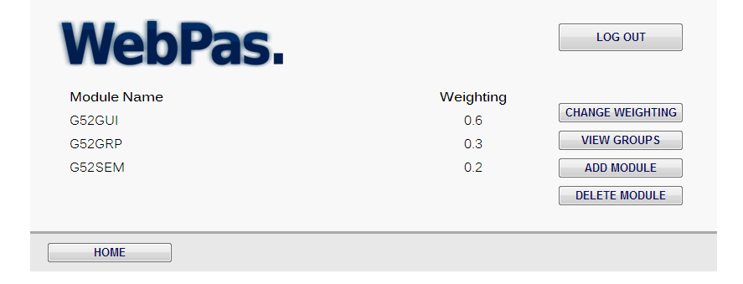
Here the modules are displayed in a webpage the module convenor can choose from the options on the right to either change the weighting , view groups , add module or delete a module.

